Tab 1

INDEX PAGE:

Introduction to salesforce—------------------------------------------------------------------------2

What is CRM—------------------------------------------------------------------------------------------3

### A CRM Application to Manage the Services offered by an Institution—------4

### Requirements—-----------------------------------------------------------------------------5

### Create Objects from Spreadsheet—---------------------------------------------------6

### Create a ScreenFlow for Student Admission Application process—----------10

### Create Users—------------------------------------------------------------------------------14

### Create an Approval Process for Property Object—--------------------------------15

### Create a Record Triggered Flow—-----------------------------------------------------16

### Create a ScreenFlow for Existing Student to Book an Appointment—--------17

### Create a ScreenFlow to Combine all the flows at one place—------------------18

### Create a lightning app page—-----------------------------------------------------------18

Challenges we faced —-------------------------------------------------------------------20

Github Repository link for our project—-------------------------------------------------------20

**Introduction to salesforce**

Salesforce is a cloud-based Customer Relationship Management (CRM) platform designed to help businesses manage their interactions with customers and streamline various business processes. Here's a brief introduction:

### What is Salesforce?

Salesforce is a Software as a Service (SaaS) product, meaning it's hosted on the cloud and doesn't require installation on local servers. It was founded in 1999 by Marc Benioff, Parker Harris, Dave Moellenhoff, and Frank Dominguez1.

### Key Features:

1. Customer Management: Stores and manages customer information, interactions, and activities.
2. Sales Management: Tracks sales leads, prospects, and opportunities.
3. Marketing Automation: Helps create, execute, and track marketing campaigns.
4. Customer Support: Facilitates handling customer issues and service requests.
5. Analytics and Reporting: Provides insights into customer data and business performance.

### Benefits:

* Accessibility: Accessible from anywhere with an internet connection.
* Integration: Integrates with various third-party applications.
* Scalability: Scales with your business needs.
* Cost-Effective: Operates on a pay-as-you-go model, reducing overhead costs.

### Products:

Salesforce offers a range of products, including:

* Sales Cloud: For managing sales processes.
* Service Cloud: For customer service and support.
* Marketing Cloud: For marketing automation and campaigns.
* Commerce Cloud: For e-commerce solutions.
* Tableau Analytics Cloud: For data visualization and analytics

**What is CRM**

CRM stands for Customer Relationship Management. It's a technology that helps businesses manage and improve their interactions with customers and potential customers. Here are some of its key aspects:

### Key Features:

* Contact Management: Stores customer information, like names, addresses, and social media profiles, in a searchable database.
* Sales Management: Tracks sales leads, prospects, and opportunities, helping the sales team stay organized and efficient.
* Customer Support: Facilitates customer service by handling customer issues and service requests efficiently.
* Marketing Automation: Automates marketing efforts, from email campaigns to social media posting.
* Analytics and Reporting: Provides insights into customer data and business performance, helping make informed decisions.

### Benefits:

* Improved Customer Relationships: Helps understand customer needs and behavior, leading to better service and satisfaction.
* Increased Sales: Streamlines the sales process, ensuring no lead is lost and sales opportunities are maximized.
* Enhanced Efficiency: Automates routine tasks, allowing staff to focus on more critical work.
* Better Data Management: Centralizes customer data, making it easily accessible and useful for strategic planning.

### Examples of CRM Systems:

* Salesforce: Known for its robust features and extensive customization options.
* HubSpot: Popular for its user-friendly interface and powerful marketing tools.
* Microsoft Dynamics 365: Integrates well with other Microsoft products and offers a comprehensive suite of tools.

CRM systems can be incredibly powerful tools for businesses of all sizes.

### **A CRM Application to Manage the Services offered by an Institution**

A CRM Application to Manage the Services offered by an Institution

A CRM (Customer Relationship Management) application can be incredibly beneficial for managing the services offered by an institution, such as a school, university, or any educational organization. Here are some key features and benefits of using a CRM application for this purpose:

### **Key Features:**

1. **Contact Management:** Store and manage contact information for students, parents, staff, and other stakeholders.
2. **Service Management:** Track and manage various services offered by the institution, such as course registrations, appointment scheduling, and case management.
3. **Workflow Automation:** Automate routine tasks and processes, such as sending reminders for appointments or follow-ups.
4. **Reporting and Analytics:** Generate reports and analytics to gain insights into service usage, performance, and areas for improvement.
5. **Customization:** Customize the CRM to fit the specific needs and workflows of the institution.
6. **Integration:** Integrate with other systems and tools used by the institution, such as learning management systems (LMS) and financial systems.

### **Benefits:**

* **Improved Efficiency:** Streamline service management processes, reducing manual effort and minimizing errors.
* **Enhanced Communication:** Facilitate better communication between students, parents, staff, and other stakeholders.
* **Data-Driven Decisions:** Use data and analytics to make informed decisions and improve service delivery.
* **Personalized Service:** Provide personalized support and services based on individual needs and preferences.
* **Centralized Information:** Keep all relevant information in one place, making it easily accessible and manageable.

### **Examples of CRM Applications for Educational Institutions:**

* **Salesforce Education Cloud:** Offers a comprehensive suite of tools for managing student services, admissions, and alumni relations.
* **Zoho CRM for Education:** Customizable CRM designed specifically for schools and universities, with features for managing admissions, student engagement, and more.
* **HubSpot CRM:** Provides tools for managing student interactions, tracking admissions, and automating marketing efforts.

### **Requirements**

1. **Admission Application Management:**Prospective students should have access to the admission application form through the institute's website or portal. The admission application form should collect comprehensive information including personal details, academic history, and qualification. Submitted admission applications should be captured and stored in the Salesforce CRM system. Students should receive automated email notifications after successful submission of application. Admissions staff should be able to generate reports and dashboards to analyze application metrics, acceptance rates, and enrollment trends.
2. **Approval Process Requirements :**Implement an Approval process in Salesforce to review and approve Consulting Request. Set up email alerts to notify relevant students when he/she is approved or rejected. Ensure that request gets automatically submitted when it is created.
3. **Consulting Services Management:**Prospective students should be able to request consulting services through the institute's website or portal. The consulting request form should capture student details, consulting preferences, and areas of expertise required. Submitted consulting requests should be recorded in the Salesforce CRM system. Consultants and advisors should receive automated email notifications for new consulting requests. Consultants should be able to view, accept, and manage consulting requests within the Salesforce CRM interface. Consulting appointment scheduling should be facilitated within Salesforce, including date, time, and purpose of the appointment. Appointment status (e.g., scheduled, completed, canceled) should be tracked and updated in Salesforce.
4. **Immigration Case Management:**Students should be able to initiate immigration cases through the phone, email or web. The immigration case submission form should capture case details, and relevant information. Submitted immigration cases should be recorded and stored in the Salesforce CRM system. Immigration agents and case managers should receive automated email notifications for new immigration cases. Immigration agents should be able to view, process, and track immigration cases within the Salesforce CRM interface. Case status (e.g., open, in progress, closed) should be tracked and updated in Salesforce. Document management and collaboration tools should be integrated to facilitate case processing and communication.

### **Create Objects from Spreadsheet**

Directly Creating Objects from Spreadsheet in Salesforce

### **Create Course object**

1. Go to your object manager and and click on create object from spreadsheet
2. Click on the link to get the spreadsheet, [Course](https://docs.google.com/spreadsheets/d/1RD3chCZ1BWZxAKQxtntArr27K1iQxiNobeTA1iWe4Dc/edit#gid=613505717).
3. After downloading, upload the file, map the fields and upload to create an object.

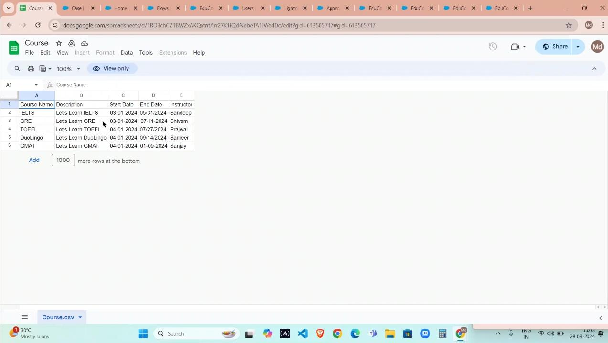 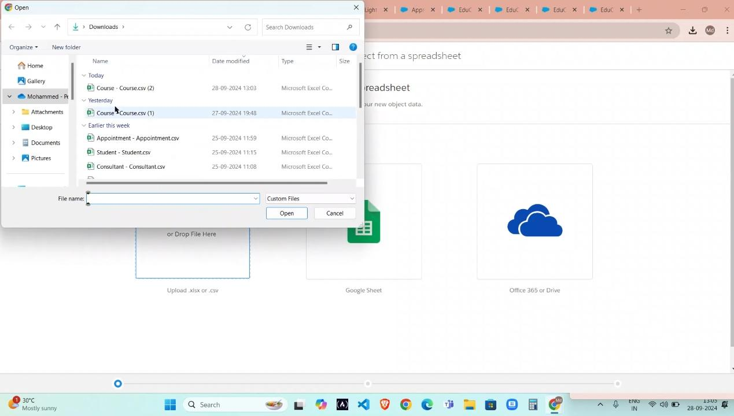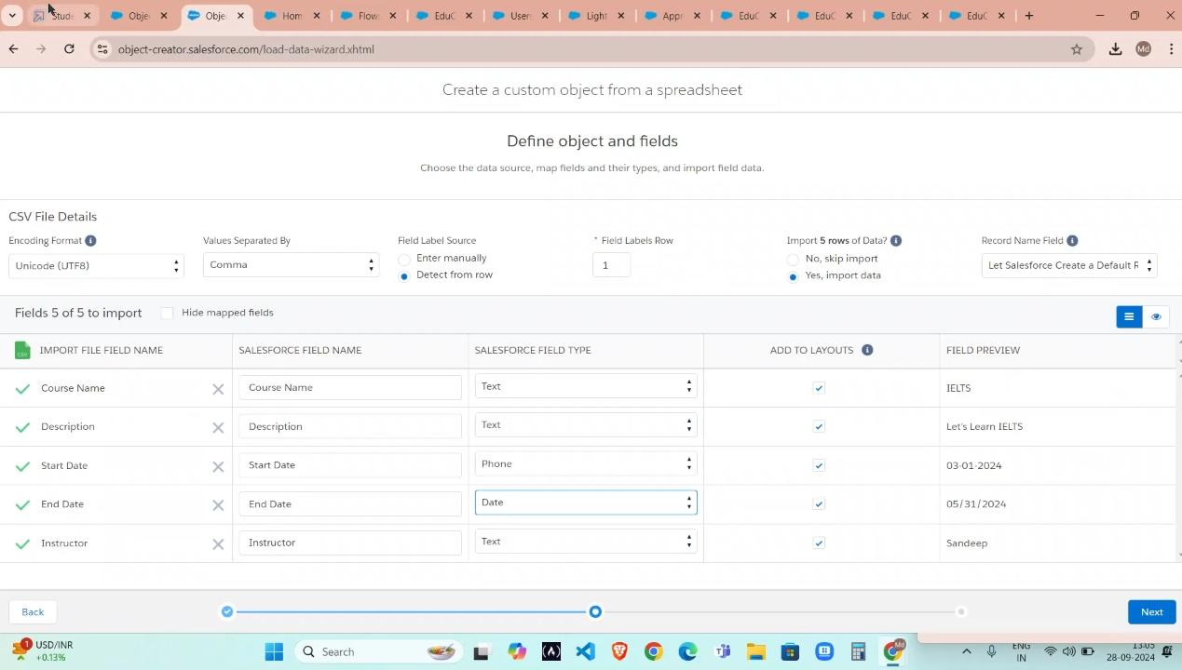

### **Create Remaining object**

1. Follow the steps which we have followed for course object creation.
2. Use the following sheets for remaining objects.
   1. [Consultant](https://docs.google.com/spreadsheets/d/12q_u-63PZ3MTCgJS1voKsvTL_jVIjW4kyI_9shgB97s/edit#gid=198933105)
   2. [Student](https://docs.google.com/spreadsheets/d/1QbkK_l1K5x9aBN8LXrEZfYJ0qMMLU-5NTi5O3_cCe1Q/edit#gid=1705718850)
   3. [Appointmen](https://docs.google.com/spreadsheets/d/1Wvk7nWFXR7xn56F8kr1WQCYs5_x6_CUZsFiZtEpVufY/edit#gid=1793530912)t

### **Configure the Case Object**

1. Go to object manager, edit case object.
2. Select the “Type” field and add the values in it.  
   Immigration  
   Visa Application
3. Now Select the “Status” field and add the values in it.  
   Open  
   In-progress

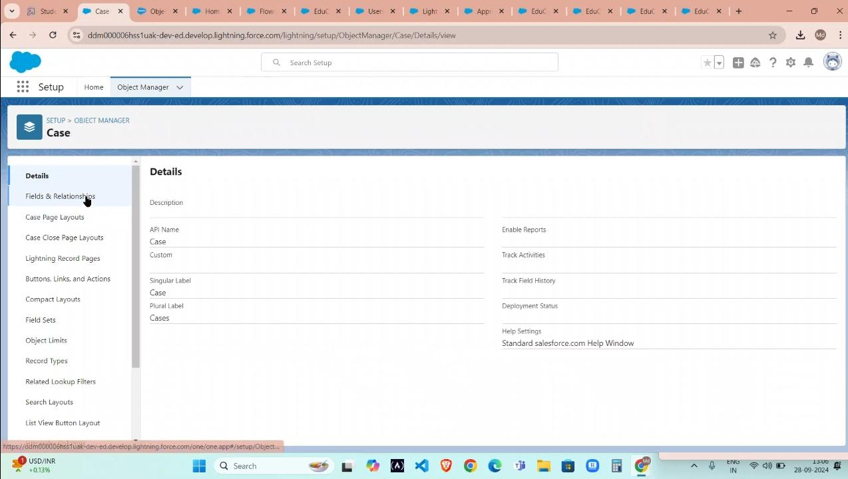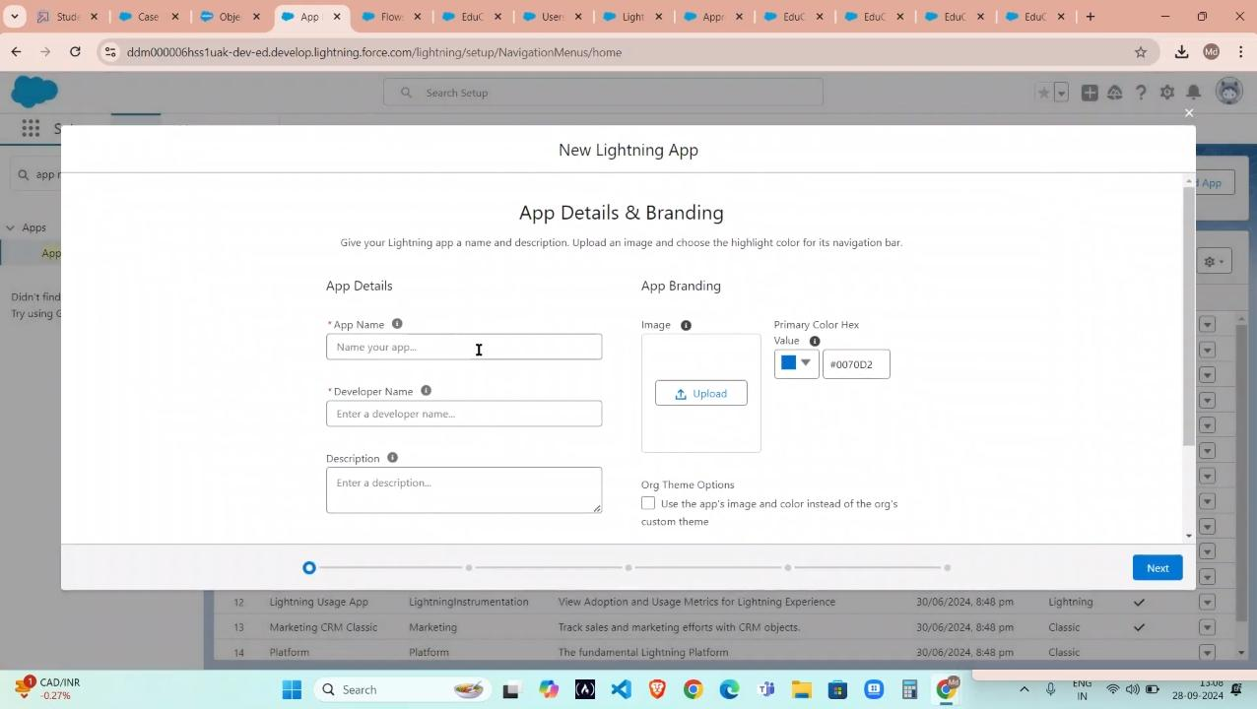

### **Create Relationship among the objects**

1. Create lookup between appointment and student, appointment and consultant.
2. Create an object to store the information student and course details with the name Registration.
3. Also create a lookup between student and case to store the student queries for immigration or visa application.
4. The data model should be similar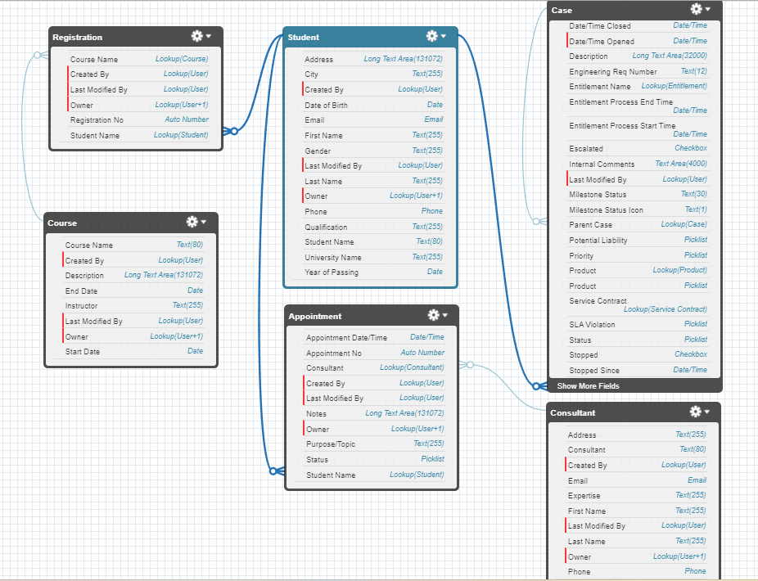to the below Data Model with fields & relationships:
5. Create tabs for the respective object.

### **Create a Lightning App**

1. Go to Setup, search for the App Manager in quick find
2. Click on New Lightning App
3. Give app name as “EduConsultPro”, click Next, Next, Next
4. Add Home, Students, Courses, Consultants, Appointments, Registrations, and Cases from the Available Items to Selected Items.
5. Add “System Administrator” profile from Available Profiles to Selected Profiles, click Save & Finish.

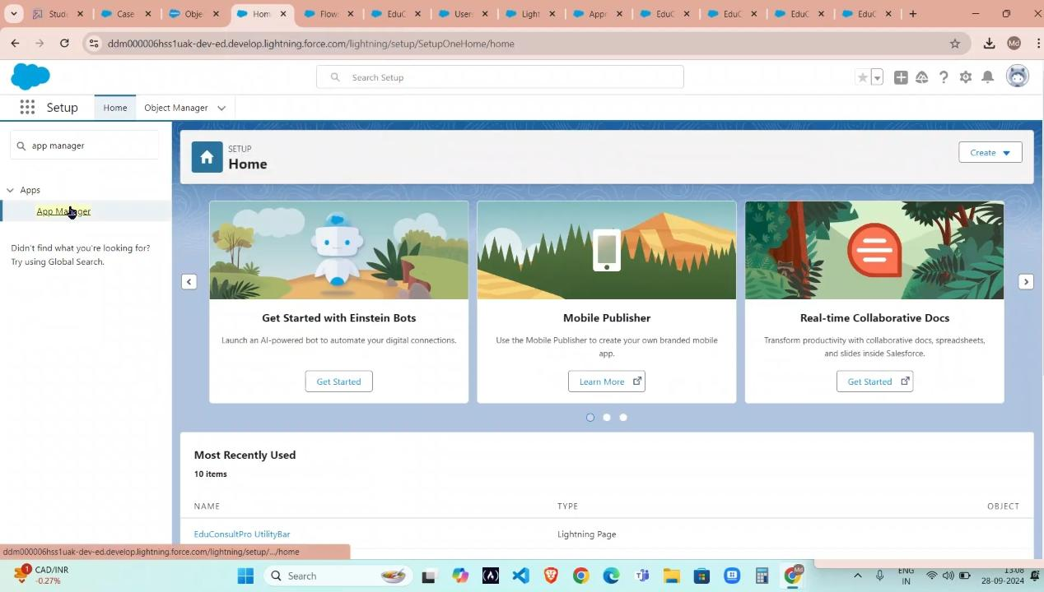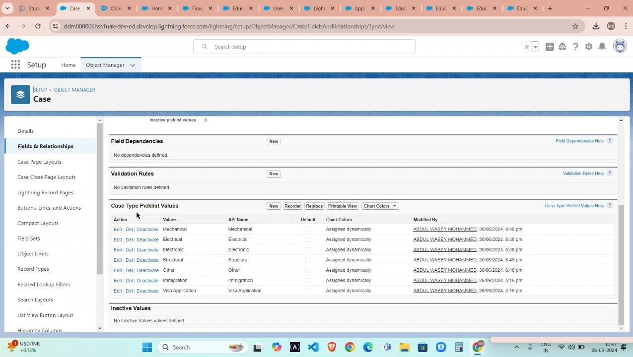

**Create a ScreenFlow for student Admission Application Process.**

**Add screen Element**

From setup, enter flow builder n quick find.select new flow screen flow and add a screen element,in the screen properties pane, for label enter student info.,click on fields,click on the record variable input and create a new resource studentrecordres to display all the fields which are in the student object . Drag all the fields which are needed to add on the screen inorder to collect the student information.

## **Create Student record using create element**

Add a create element after student info screen element,label it as create student record.select one under how many records to create, and select use all values from a record under how to set the record fields.select the record variable resource student records which we have created in the student info screen element, under create a record from these values.

## **Add screen element**

Add a screen element after create student record element and label it as course screen.add a picklist component from the left side panel label it as select course,under choices type IELTS and enter. This creates a variable with the name IELTS. Repeat the same for GRE,GMAT,duolingo,TOEFL.

## **Add Decision element**

Add a decision element after selecting the course screen element,label it as selecting course. Under outcome label it as selected IELTS and write the condition such as below:

Resource:select course screen component from select course screen element

Operator:equals

value:IELTS choice variable from select course screen element.

Click on the “+” icon and repeat the same process for other options mentioned as below:

a.GRE

b.GMAT

c.Dulingo

d.TOEFL

And click the done button in the bottom of the decision element page.

## **Create Email text template variables for email body and subject**

"Dear (IStudentRecord Res.Name),

Congratulations and welcome to EduConsultant Prol

We are delighted to inform you that your registration on our platform has been successfully completed. You are now part of our esteemed community dedicated to empowering students like you to achieve their educational and immigration aspirations.

At EduConsultantPro, we understand the importance of your academic and career goals, and we are committed to providing you with the highest level of support and guidance throughout your journey

Here are a few key points to help you get started Explore Our Resources. Take some time to explore the wide range of resources, tools, and services available on the EduConsultant Pro platform. From educational insights to immigration advice, we offer comprehensive support tailored to your needs

Connect with Our Consultants: Our team of experienced consultants is here to assist you at every stage of your educational and immigration endeavors. Don't hesitate to reach out to us with any questions, concerns, or inquiries you may have. We're here to help!

Stay Updated: Keep an eye on your inbox for important updates, announcements, and exclusive opportunities from EduConsultant Pro. We'll ensure that you're informed about the latest developments and relevant information to support your journey

Engage with the Community Join our vibrant community of students, professionals, and experts who share your passion for education and global opportunities Connect with like-minded individuals, participate in discussions, and expand your network

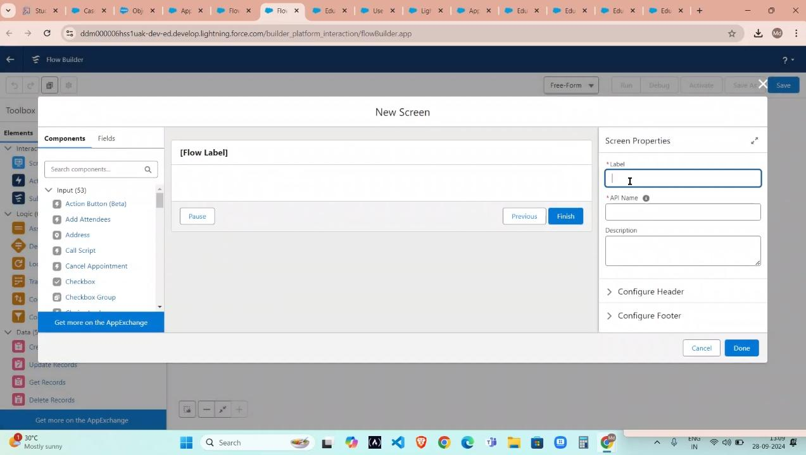

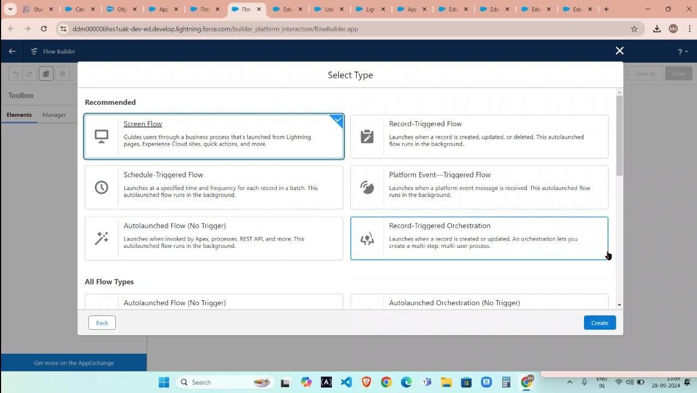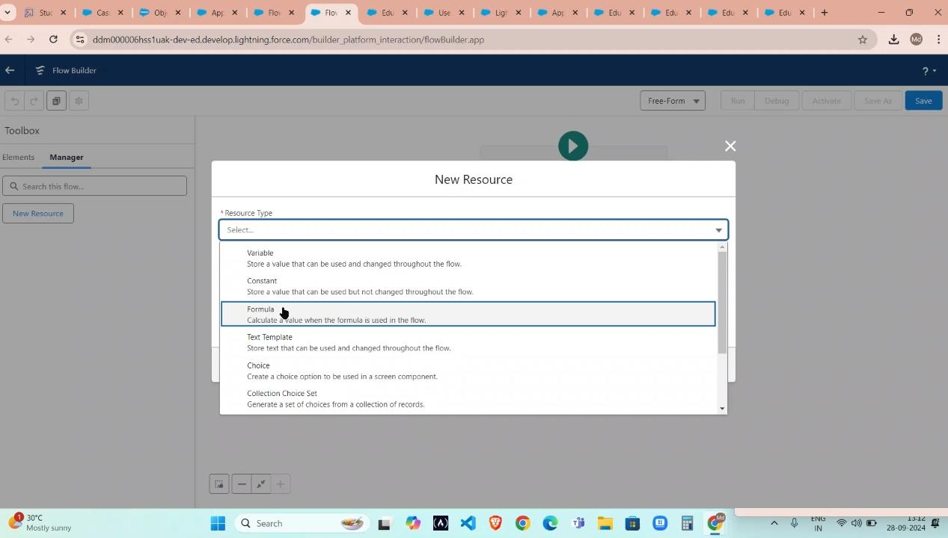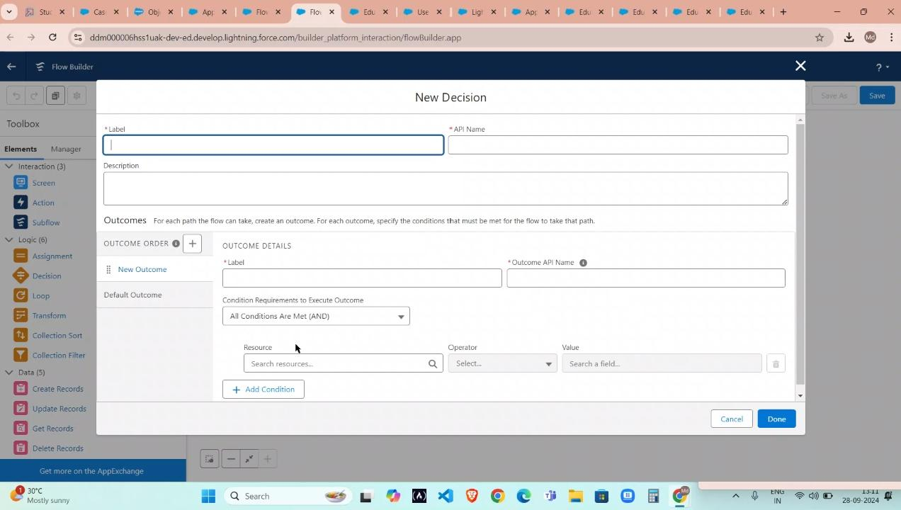

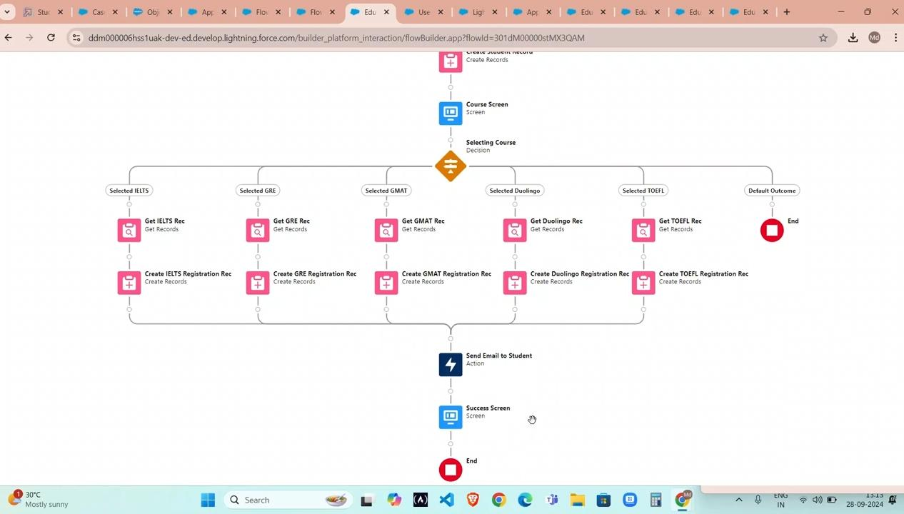

## **Create Users**

Create users

Creating users in salesforce go to setup click administration and click users and choose the new user and the

Last Name : consultant

License : salesforce platform

Profile : standard platform use

And then fill all the mandatory fields and save it.

Configure the user settings

Steps that we followed in this configurations are

Go to setup click administration users and click edit next to your name

Then scroll down to bottom.under approver settings,select consultant the manager and

Click save.

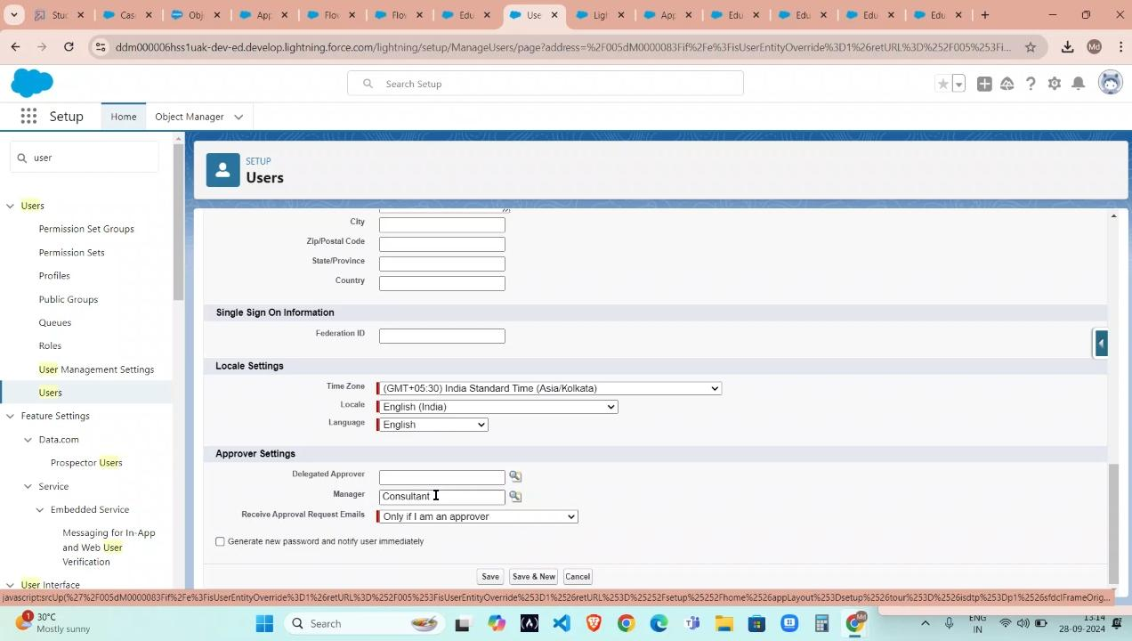

## **Create an approval process for property object**

Create an email template

From setup enter templates in the quick find box and then select lightning email templates, toggle on. And go to app launch,search for email templates, create a new folder with the desired name. Then create a new email template, select the folder which we have created in the previous steps, enter the below text in the HTML value and save it as submission template.

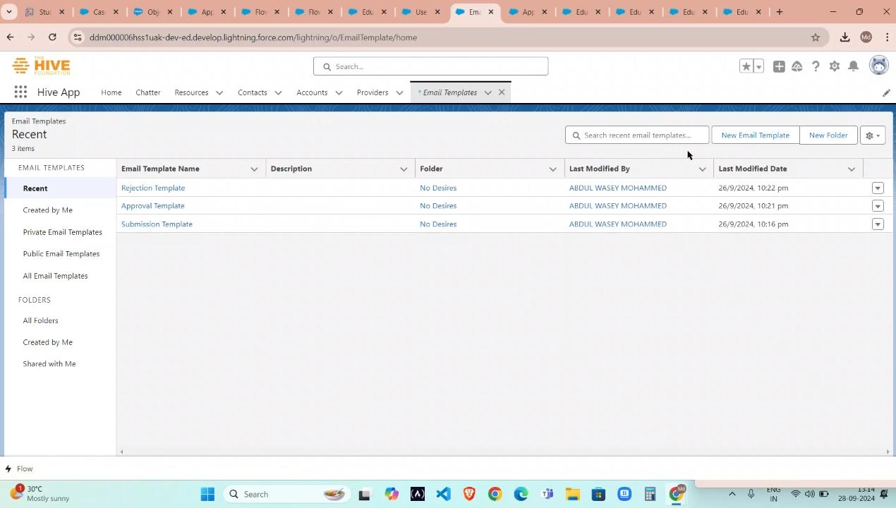

Create an approval process

From setup enter approval in the quick find box, and then select approval processes. In manage approval processes for select appointment and click create new approval process use jump start wizard. Then configure the approval process. And then process name is appointment approval,unde select approver, select manager for the option: automatically assign an approver using a standard or custom hierarchy field. Click next and next automated approver determined by select manager . from record editability properties click on administrator or the currently assigned approve can edit records during the approval process. Save the approval process. And click view approval process detail page. Under initial submission actions, click add new in the field update, and configure it with these values.

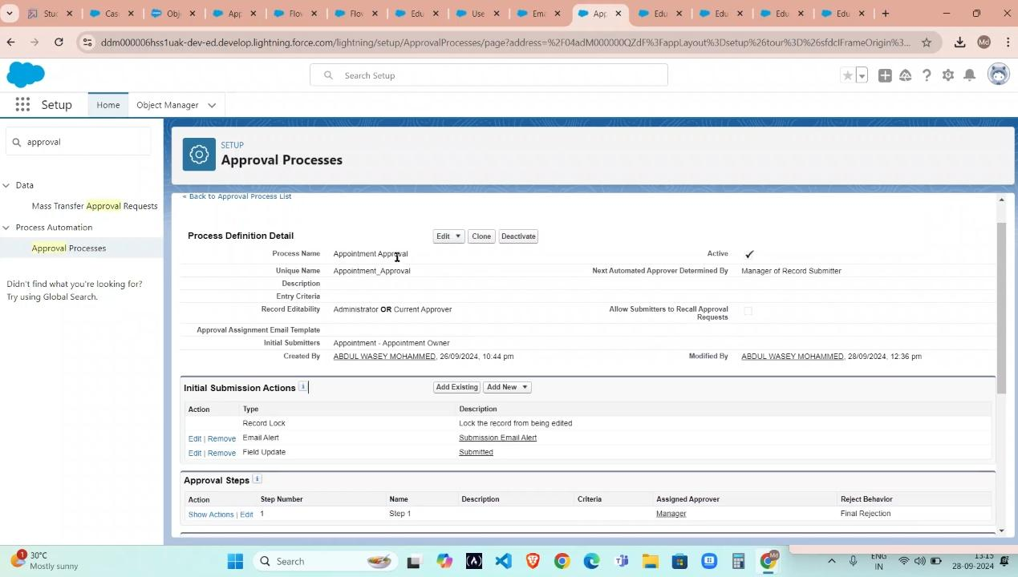

## **Create a record triggered flow**

Configure the start element

From setup enter flows in the quick find box then select flows and click new flow. Select record triggered flow.click create the configure start window opens. For object select appointment for trigger the flow when, select a record is created the flow will look like this

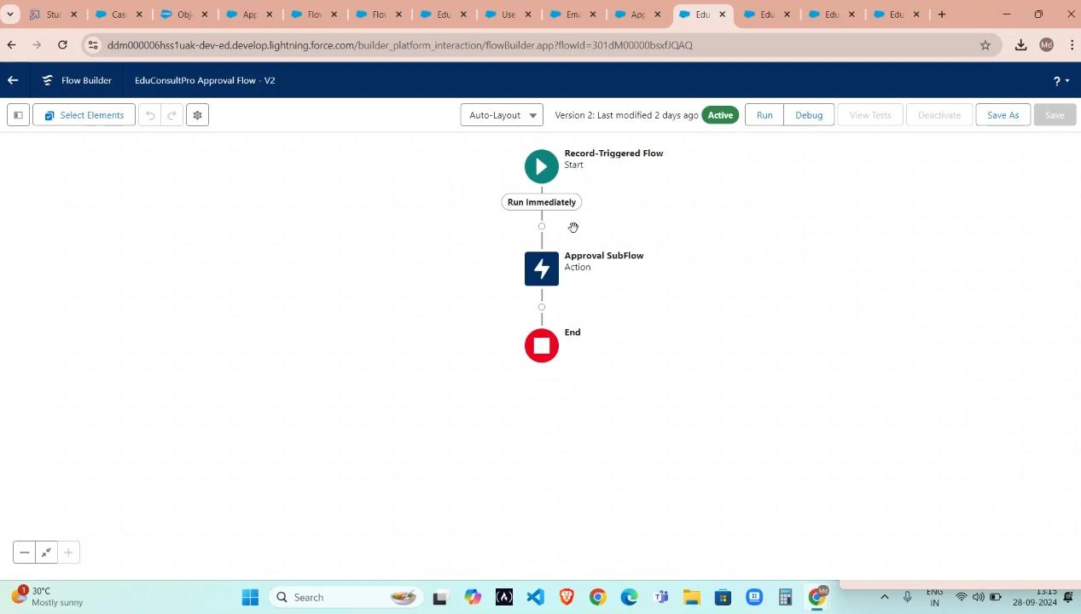

Add an action element

Add an action element after the start element and select the submit for approval action, label it as approval subflow and set the recordid to “record.id” .

And use the normal default option and picks for the other elements options

Just enter the record id and the other options are all filled by mandatory and other options are default picks and they are already choose in default settings in the flow options

Creating flow the most important thing to notice is a spelling mistakes and is there any spelling mistake are rise then further options and further details are going to be mistaken

‘

And once we choose the flow api name or a label name just choose the label name the default settings are choose the api name for the given label named app or flow

Same label name can be used more times and it is comfortable to use also

But the same API name cant be allowed because the system understand only api name not the labeled name in the flow or app we create.

## **Create a screenflow for existing student to book an appointment**

To create a screenflow for existing student to book an appointment we need to break the process in step by step and we already created a flow using the same steps we are going to create a new flow for existing student to book an appointment the steps we are going to follow they are:

1. Add screen element
2. add GET record element
3. Add decision element
4. Add screen element
5. Add get record element
6. Create appointment record using create records element
7. Add screen element
8. Add an subflow element

After we create all elements our flow will look like this exactly. We can even add some further details and further information as we need .

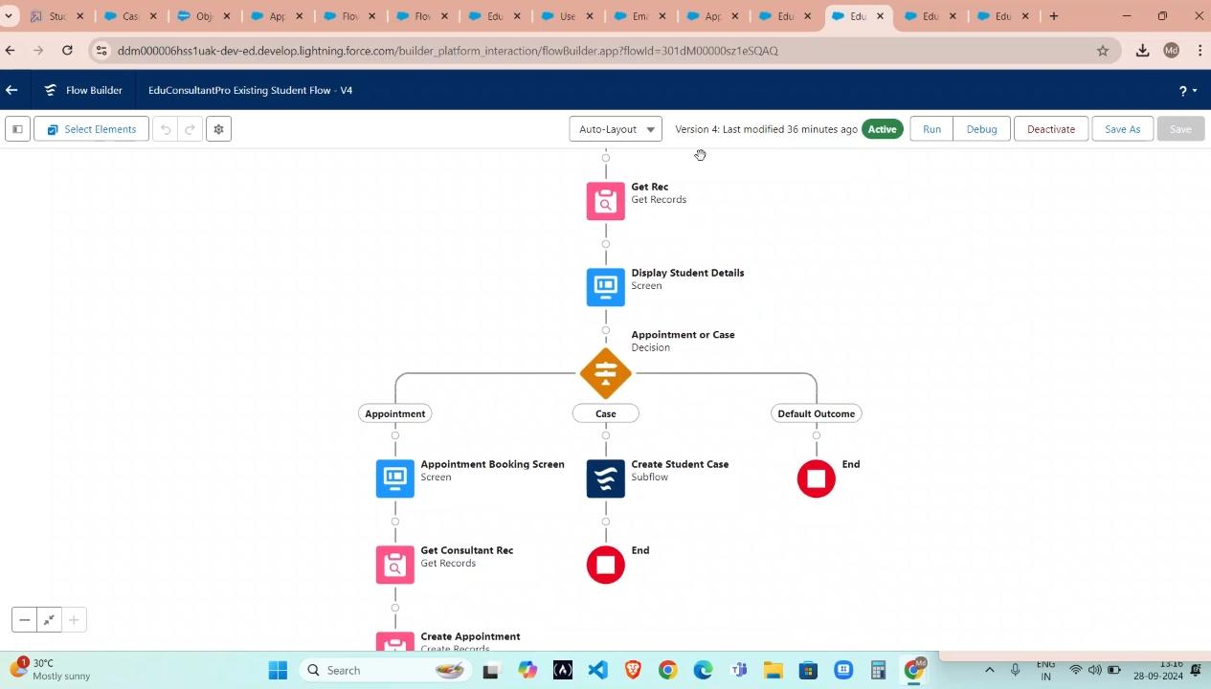

## **Create a screenflow to combine all the flows at one place**

We are creating more flow in this project now we need to combine all the flow into one flow

To do this we need a one proper flow and we are going to add a subflow what are all we created.

The steps to do this flow is

1. Add screen element
2. Add screen element
3. Add decision element
4. Add an subflow element
5. Add an subflow element

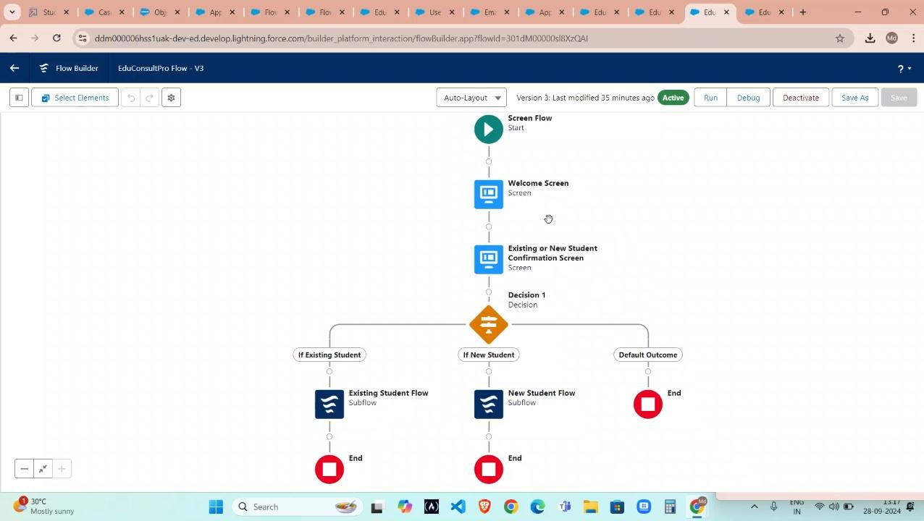

## **Create a lightning app page**

1. From setup enter app builder in the quick find box, then click lightning app builder.
2. Click new,select the home page,then click next.
3. Setup through the wizard and name the page educonsultpro home page select the standard home page template, and then click done.
4. Drag the flow component to the top right regin.
5. Search for the educonsultantpro flow and click save.
6. Click activate, click app and profile,then click assign to apps and profiles.
7. Select the sales app, then click next
8. Scroll down the list of profiles and select system administrator, then click next
9. Review the assignment and then click save.

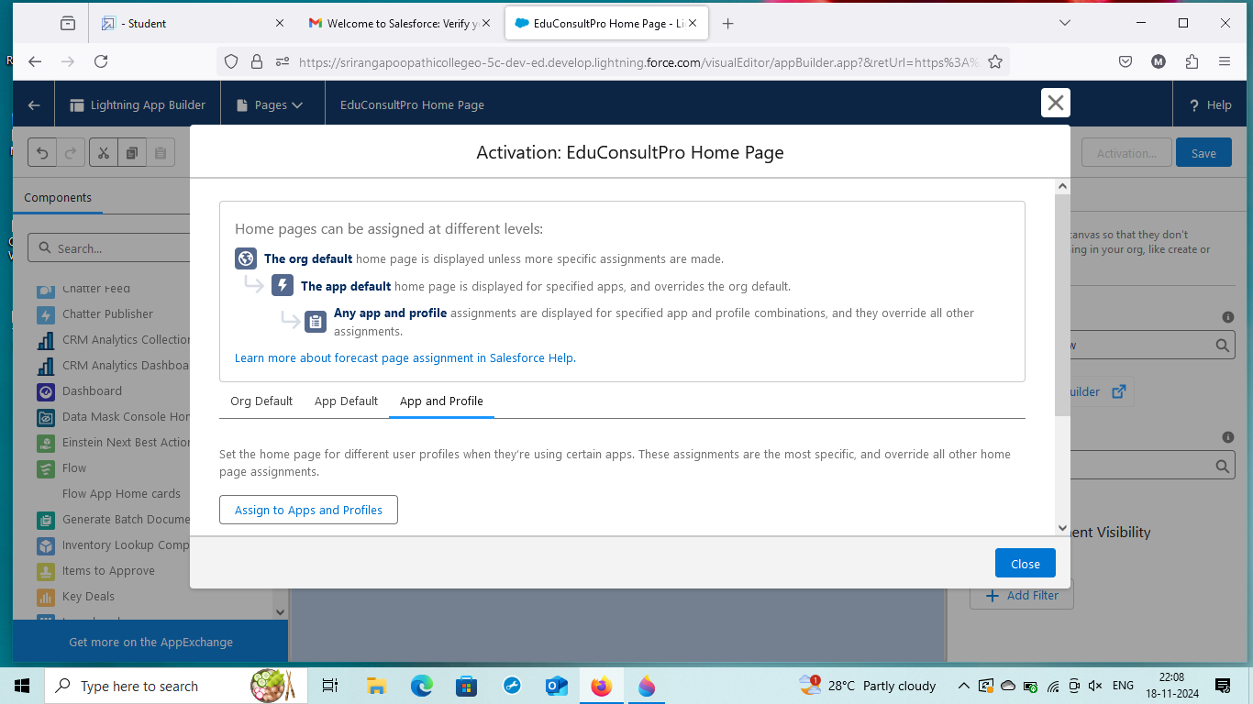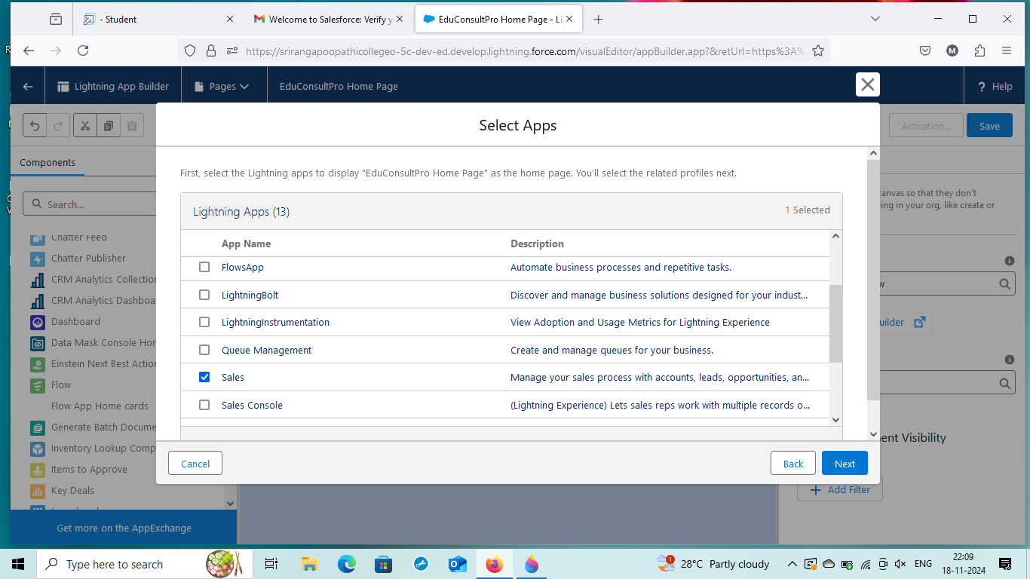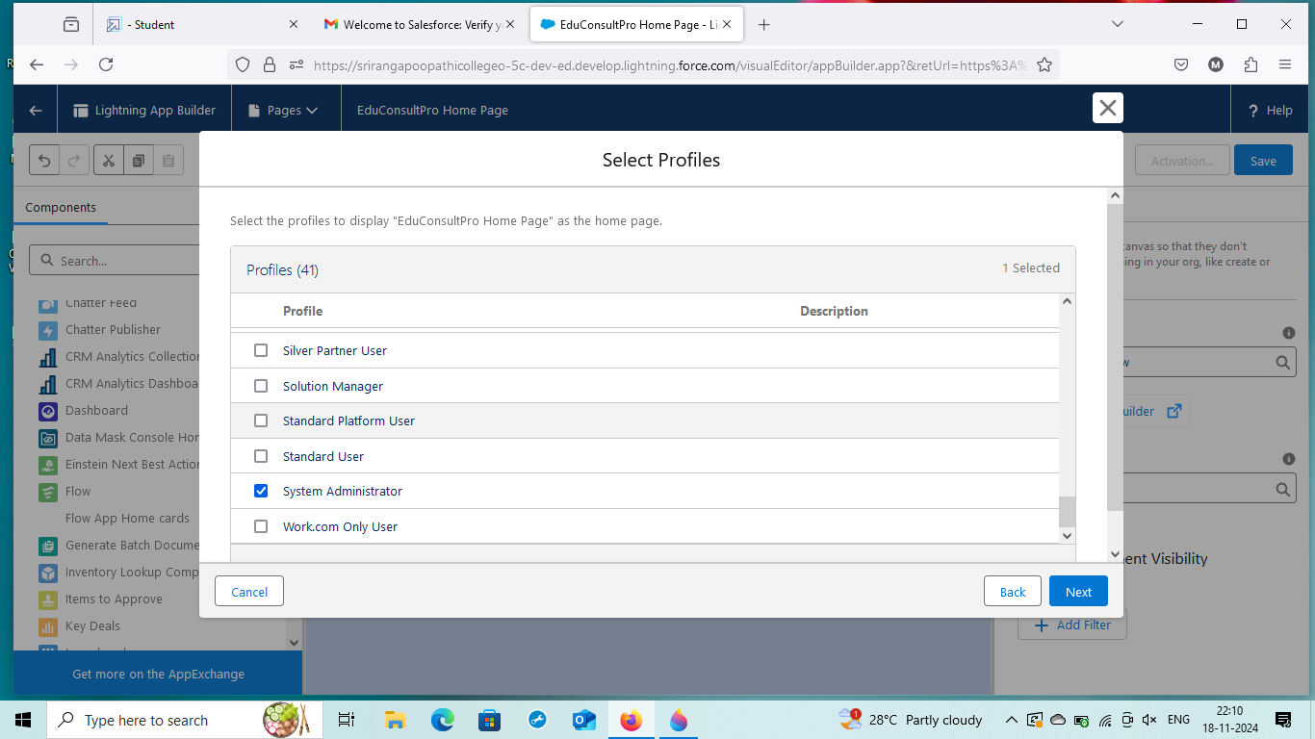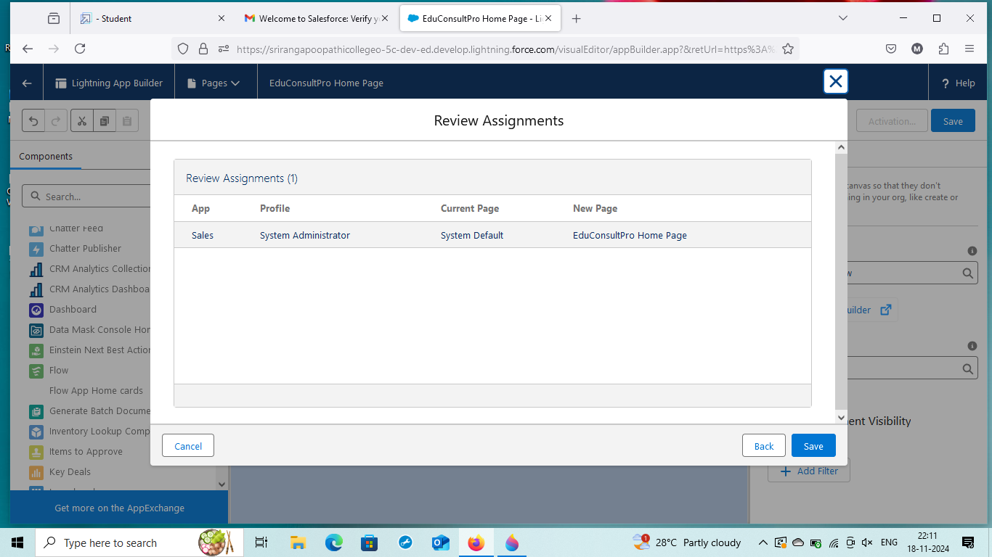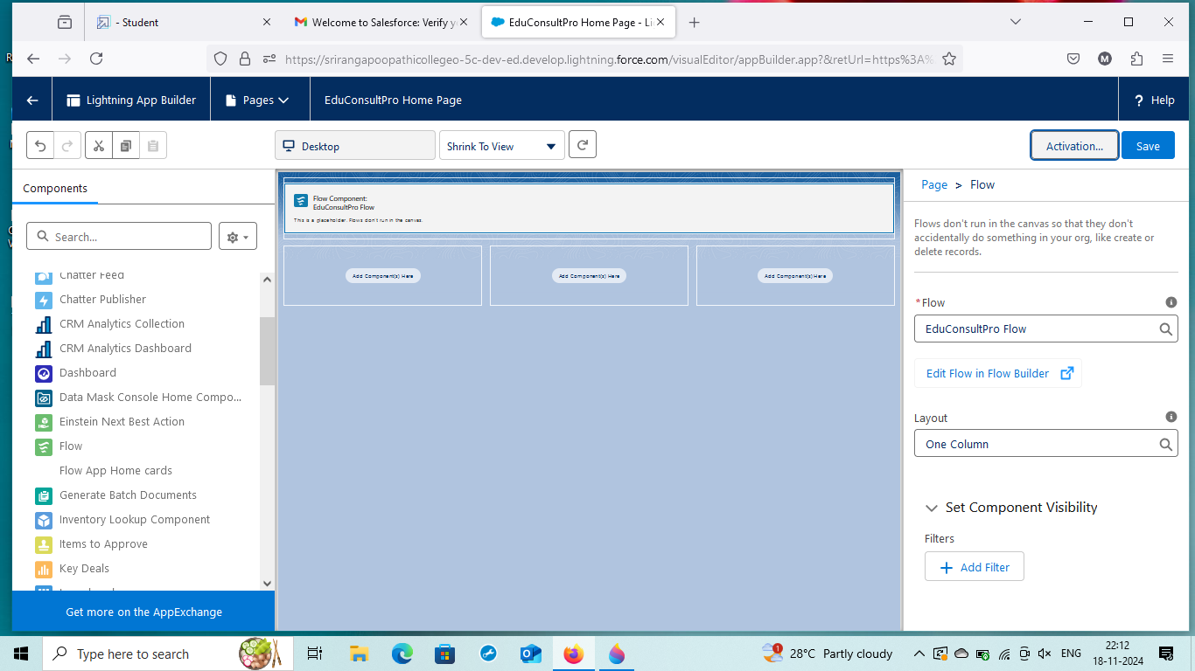

## **Challenges we are faced during this project:**

### **1. Data Migration:**

Transferring existing data into the new CRM system can be a complex and time-consuming process. Ensuring data accuracy and integrity during migration is crucial.

### **2. Cost:**

Implementing a CRM system can be a significant investment, especially for smaller institutions. The costs include not only the software itself but also the time and resources required for implementation and ongoing maintenance.

### **3. User Adoption:**

Ensuring that all users, including faculty, staff, and students, are effectively using the CRM system can be challenging. Continuous training and support are essential to encourage widespread adoption.

### **4. Data Security:**

Protecting sensitive student data is paramount. The CRM system must have robust security measures in place to prevent unauthorized access and data breaches.

### **5. Customization:**

Each institution has unique needs and workflows, so the CRM system may need to be customized to fit these requirements. This can add complexity and require additional development work.

### **6. Performance Monitoring:**

Regularly monitoring the performance of the CRM system and making necessary adjustments is essential to ensure it continues to meet the institution's needs effectively.

## 

## **GITHUB REPOSITORY:**

<https://github.com/Mohan0837v/A-CRM-Application-to-Manage-the-Services-offered-by-an-Institution>

